REL101: Introduction to Religion

Professor Steven Daniel Sacks

Office Hours MW 10:00-12:00, Th 11:30-12:30 and by appointment

email: ssacks@cornellcollege.edu

Class Schedule: MTuW 12:15-3:00 ThF 9:00-11:15 Thomas Commons - Beijing

**Religion is a cornerstone of humanity, but what is it, and why does it exist? This course will explore the place of religion in human civilizations and cultures, examining the ways human beings create and engage meaning. Although students will encounter myth and rituals from disparate areas of human history and culture, this course is not a survey of world religions. In order to develop critical thinking in the field of religion, students will engage religion as a way of thinking and experiencing the world.**

The content and methods correspond to Cornell’s educational priorities as follows:

1. **Knowledge**: Students will integrate and apply knowledge from an interdisciplinary perspective in order to understand the topics of Religion; since no methodology of the academy is “native” to the study of religion, a variety of methodological perspectives are employed in this course.
2. **Inquiry**: Students will encounter a variety of interpretive schema, and will be asked to produce critical analysis to discern the benefits and detriments of differing interpretations and positions.
3. **Communication**:Students will be asked to develop skills in oral presentation and argumentation in every class session as well as in formal and informal written assignments, and to provide clear structured arguments on written assignments, with ample use of source materials.
4. **Intercultural Literacy:** Students will be asked to identify with, argue on behalf of and critique a variety of perspectives and positions with which they do not personally identify.
5. **Ethical Behavior:** The study of the history and interpretation of religion is an ethical endeavor, and we will encounter a variety of ethical problems throughout the course.

Textbook: Kessler, Gary E. *Studying Religion: An Introduction through Cases* 3rd Edition McGrawHill; Boston 2007); additional readings are available online on moodle.

Class attendance and participation are compulsory for this course, as is the originality of your work; absences without verifiable cause or plagiarism will be cause for failing grades. Late final papers or missed exams will be subject to a minimum of a half-grade penalty. Failure to submit an assignment may be penalized by failure in the course.

Grading:

Student Success 20%

Class participation 20%

Exam (2) 30%

Papers (2) 30%

All readings are listed below, due on the day that they appear, and may be downloaded from our Moodle forum. Attendance and contribution to our class discussions are expected on a daily basis. You are expected to bring your readings to class every day. Completion of daily written responses must be posted on moodle at least two hours before class.

I will hold regular office hours 11:00-12:30 Monday through Thursday, but please feel free to contact me any time with questions or concerns about the course. The present schedule and/or readings are liable to be amended as is necessary. Students are expected to complete a significant amount of work outside of the course which supplements scheduled hours within the classroom, and exceeds the government’s regulations on course credit equivalency.

Students should only miss class in circumstances documented by a note from the health center, or similar form of external verification; exceptions may be made in circumstances deemed to be exceptional by the instructor. Three absences may be cause for a failing grade.

Cornell College expects all members of the Cornell community to act with academic integrity. An important aspect of academic integrity is respecting the work of others. A student is expected to explicitly acknowledge ideas, claims, observations, or data of others, unless generally known. When a piece of work is submitted for credit, a student is asserting that the submission is her or his work unless there is a citation of a specific source. If there is no appropriate acknowledgement of sources, whether intended or not, this may constitute a violation of the College’s requirement for honesty in academic work and may be treated as a case of academic dishonesty. The procedures regarding how the College deals with cases of academic dishonesty appear in The Catalogue, under the heading “Academic Honesty.”

Students who need accommodations for learning disabilities must provide documentation from a professional qualified to diagnose learning disabilities. For more information see cornellcollege.edu/disabilities/documentation/index.shtml

1. What is required as class participation?

Students are required to have an intimate knowledge of the day’s readings, and should bring current readings and assignments to class. You will be assigned to a group of six classmates who will work inside and outside of class to reinforce one another’s understanding of the course and the questions raised from the material that we will study.

In order to prepare for each class, you will be required to do the following:

1. Marginalia: Print out every reading, and every time you feel the urge to highlight or underline something, write out in the margins why you wanted to underline it. Why is that passage important? Is it a major new point in the argument? A significant piece of support? A summary of the opposition? A particularly strong or particularly weak point? Use the margins to summarize the text, ask questions, give assent and protest vehemently – do not just color the pages. You will scan and electronically submit your marginalia on Fridays.
2. Leadership: Every day one member of your group will assume the role of leader and (a) compose and post a thesis seeking question to our moodle forum by 7:00 PM the evening before class; this question will seek to clarify the intent and/or argument of our readings – the question will not address questions of fact or content, but rather arguments presented in our readings; (b) observe, record and present the group’s consensus solution from class and online discussion; the product should not be a summary of “what the group talked about” but a persuasive presentation of the group’s work, and summary of their consensus solution to a problem in a one sentence thesis statement, where appropriate. All written efforts should be posted on Moodle.
3. Online Circular Response: In response to a question posed by the day’s leader, every member of the group will post a response on our moodle forum of at least three sentences. Unless you are the first to respond, every member of the group is expected to post with a reference to the observations and views of a previous classmate’s contribution and make specific reference to the reading itself. All responses are due a minimum of two hours before class.
4. Communication: Every student must strive to contribute to a community of learning, and to foster good communication. The structure of this class is intended to assure that students are both prepared to contribute, and will feel free to do so in a way that is most comfortable to so, both with me and with your classmates.

2. What am I expected to know in the exams?

You will not be expected to familiarize yourself with every detail of the readings, but those which come up in class or are the subject of particular emphasis in the book or class are fair game. Our interest in these exams is not only to test your ability to recollect random facts, but rather to read critically, as well as identify and engage ideas that are relevant to your work throughout the course.

3. What is expected for writing assignments?

Papers will demonstrate your engagement with the themes and topics that pervade the readings, and allow independent reflection on their meaning. Your discussion should accomplish the following tasks: (a) provide a thesis statement in response to the chosen question (b) evidence that is drawn from the readings to defend the thesis (c) an analysis of evidence that ties the evidence to thesis, and provides a context for your thesis argument. In this course, you have a series of opportunities to develop your skills in writing and argumentation, and you may refer to the rubric that will be provided with each paper in order to assess your own work. S**tudents must submit all drafts, notes and doodles along with their final copy.**

Rubrics

Class Participation:

The grade for class participation will be categorized as follows: “A” for exceptional contributions to our daily discussions and the Moodle forum, with no missing or late assignments. “A-“ for exceptional contributions, with one missing or late assignment; “B+” for excellent and consistent contributions to our daily discussions and the Moodle forum; “B” for solid contributions to our daily discussions or Moodle forum, with one or two missing or late assignments; “B-” for uneven contributions to our daily discussion or the Moodle forum; C+ for uneven contributions to our daily discussion and the Moodle forum, with two or three missing or late assignments; “C” and below for poor effort to participate in our daily discussions and the moodle forum, with three or more missing or late assignments.

Papers:

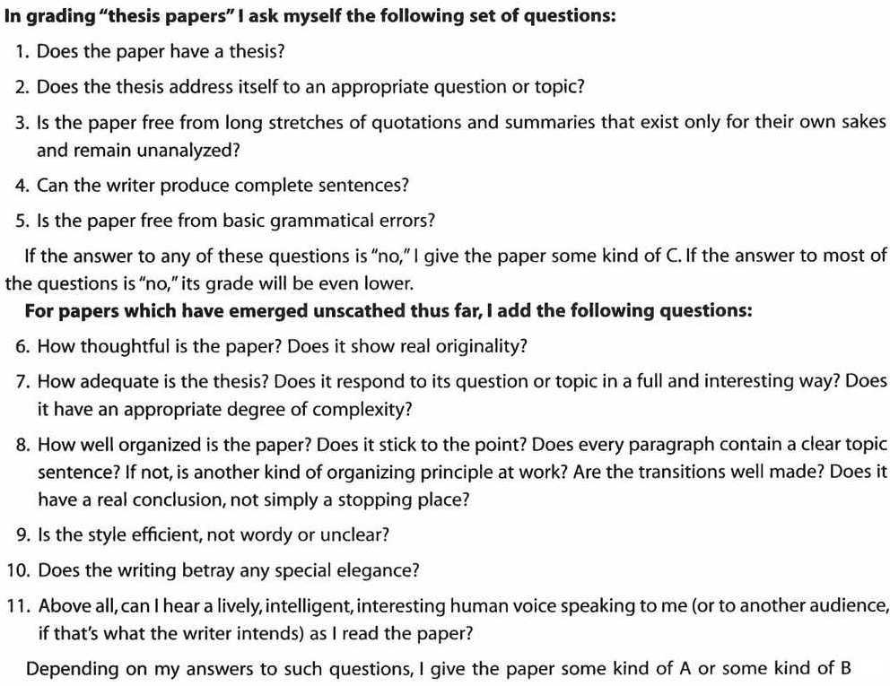

**Student Success Component**

The student success component of your FYS extends beyond the first block, to encompass activities and reflection assignments throughout Blocks 1, 2, and 3.   Block 1 focuses on time management with an emphasis on helping you manage their academic responsibilities, campus involvement, and personal wellbeing.  Block 2 emphasizes civil discourse and intercultural literacy. Block 3 focuses on academic planning and future opportunities.

Student success assignments will comprise 20% of your final FYS grade.  These assignments will be evaluated by your FYS success instructor. You and your academic advisor will be informed of your preliminary in-progress grade at the end of Block 1 (which will not include student success assignments) and you will receive your final comprehensive grade at the end of Block 3.

**Evaluation of Student Success Assignments**

**ALL** of the following criteria must be met for each assignment in order to earn full credit (4 points):

* Attendance at associated meetings and activities
* Thorough and in-depth reflection on all but one question.  All questions must be addressed at more than a minimal level.
* The quality of writing does not limit understanding of the reflection.
* Answers are complete sentences and make sense without reading the question.

If any **ONE** of the following criteria is met, then the assignment earns minimal credit (1 point).

* Inattentive or disruptive attendance (being late, not paying attention or not listening to others, talking to neighbors, sleeping,  texting, rude comments, etc)
* One or more of the responses does not or only minimally addresses the question
* The quality of writing limits the reader’s ability to understand the reflection
* Answers are not complete sentences or do not make sense without reading the question first.

Assignments falling in between these criteria will earn partial credit (2 points)

Failing to attend or failing to submit a reflection results in no credit (0 points).

See Assignment Rubrics for more details.

Without either prior approval or evidence of a serious emergency: late student success assignments will not be accepted.  If an extension is needed, please consult with your FYS success instructor prior to the assignment deadline.

**Options for Revising Student Success Assignments**

Student may revise up to 3 assignments for which they did not receive full credit.  Assignments from Block 3 are not eligible for revision.

For each revised assignment, the following must be completed:

* Students must have attended the relevant activities, participated appropriately, and submitted an initial assignment on time (or if given an extension, by the agreed upon deadline).
* Students must either work with a writing consultant or attend a writing studio workshop on revising their reflection.
* Students must review the rubric and comments provided by the FYS success instructor,  make the relevant changes, and submit both a revised reflection and an overview of the revision indicating in bullet points how they addressed each of the concerns raised in the rubric and comments.
* Revisions must be submitted via Moodle within one week of the return of the assignment.

Schedule

Friday, August 24: Introductions

Monday, August 27:

Brown, Roediger and McDaniel *make it stick* Chapters One and Eight 1-22 and 200-225.

Tuesday, August 28:

*Studying Religion*, Chapter One and Two pages 1-24 and 24-37.

Wednesday, August 29:

*Studying Religion* , Chapter Three, pages 38-59.

Levy-Bruhl, L. *How Natives Think* 69-90.

Thursday, August 30:

Spinoza, B. *Theological-Political Treatise* (Shirley, S. trans.) 1-8.

Evans-Pritchard, E.E. *Witchcraft, Oracles and Magic Among the Azande*, 64-83.

Friday, August 31:

Paper Session with Jennifer Haigh

Sunday, September 2:

**\*\*First Paper Draft Due\*\***

Monday, September 3:

*Studying Religion*, Chapter Six pages 103-126.

Eliade, M. *The Sacred and the Profane* (from Olson, *Theory and Method*) 161-168.

Tuesday, September 4:

*Studying Religion*, Chapter Seven, pages 127-158

Ibn Al-Arabi *The Ringstones of Wisdom* 3-5.

**\*\*Paper Conferences\*\***

Wednesday, September 5:

**\*\*Time Management for Academic Success  Thomas Commons – Hedges 10:00 AM\*\***

*Studying Religion*, Chapter Four, pages 60-81.

Freud, S. *Moses and Monotheism* 3-15.

Exodus 1-14 (The Story of Moses and the Exodus) (see <http://www.mechon-mamre.org/p/pt/pt0201.htm> )

**\*\*First Paper Final Due\*\***

Thursday, September 6:

*Studying Religion*, Chapter Twelve 276-299.

Luhrmann, T.M. *When God Talks Back* 72-100.

Friday, September 7:

*Studying Religion*, Chapter Five, pages 82-102.

Girard, R. *Violence and the Sacred* (from Grimes, *Readings in Ritual Studies*) 239-256.

Monday, September 10:

**\*\*\*First Exam\*\*\***

Tuesday, September 11:

**\*\*Well-being and Self-care Thomas Commons – Beijing 9:00 AM\*\***

*Studying Religion*, Chapter Eight, pages 159-185.

Primo Levi, *Survival in Auschwitz*

Hobbes, *The Leviathan*

Wednesday, September 12:

*Studying Religion*, Chapter Nine 186-209.

Al-Shafi’i, M. *al-Risala fi Usul al-Fiqh* 288-294 and 309-310.

Thursday, September 13:

*Studying Religion*, Chapter Eleven 240-275

Smith, J.Z. *Imagining Religion: From Babylon to Jonestown* 102-120.

Friday, September 14:

Paper seminar with Jennifer Haigh

Sunday, September 16:

**\*\*Second Paper Draft Due\*\***

Monday, September 17:

**\*\*Paper Conferences and Review Session\*\***

Tuesday, September 18:

**\*\*Second Exam\*\***

Wednesday, September 19:

**\*\*Second Paper Final Due\*\***